RH OVE Deployment Documentation

Red Hat OpenShift Virtualization Ecosystem Team

2025-08-04

Table of Contents

# Deployment

## Prerequisites

### Prerequisites

#### Overview

This document outlines the prerequisites for deploying the RH OVE ecosystem, including infrastructure requirements, software dependencies, and configuration prerequisites.

#### Infrastructure Requirements

##### Hardware Requirements

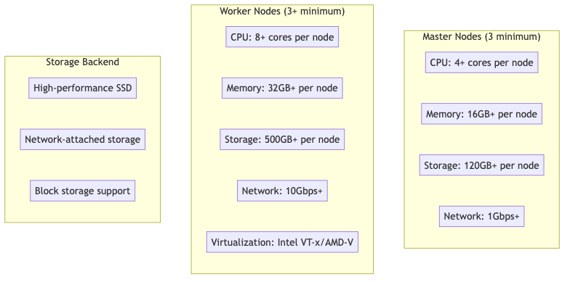

##### Virtualization Support

Ensure hardware virtualization is enabled:

### Check for Intel VT-x  
grep -E "(vmx|svm)" /proc/cpuinfo  
  
### Check if virtualization is enabled in BIOS  
lscpu | grep Virtualization  
  
### Verify KVM modules are loaded  
lsmod | grep kvm

##### Network Requirements

* **Cluster Network**: Internal cluster communication
* **Service Network**: Service-to-service communication
* **Pod Network**: Pod-to-pod communication
* **External Access**: Load balancer and ingress traffic

### Network configuration example  
cluster_network:  
 cidr: "10.128.0.0/14"  
 host_prefix: 23  
  
service_network:  
 - "172.30.0.0/16"  
  
machine_networks:  
 - cidr: "192.168.1.0/24"

#### Software Prerequisites

##### OpenShift Container Platform

* **Version**: OpenShift 4.12+ (recommended 4.14+)
* **Installation Method**: IPI (Installer Provisioned Infrastructure) or UPI (User Provisioned Infrastructure)
* **Cluster Admin Access**: Required for operator installation

##### Required Operators

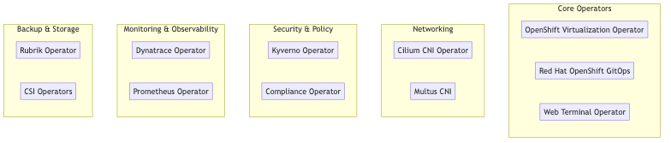

##### Storage Requirements

###### Container Storage Interface (CSI) Drivers

### Example CSI StorageClass  
apiVersion: storage.k8s.io/v1  
kind: StorageClass  
metadata:  
 name: rh-ove-ssd  
provisioner: ebs.csi.aws.com  
parameters:  
 type: gp3  
 encrypted: "true"  
reclaimPolicy: Delete  
volumeBindingMode: WaitForFirstConsumer  
allowVolumeExpansion: true

###### Storage Classes Required

* **Fast SSD**: For VM boot disks and high-IOPS workloads
* **Standard HDD**: For data storage and backup
* **Archive**: For long-term storage and compliance

#### Network Prerequisites

##### DNS Configuration

### DNS configuration for cluster  
dns:  
 base_domain: "ove.example.com"  
 cluster_domain: "cluster.local"  
metadata:  
 name: "rh-ove-cluster"

##### Load Balancer Configuration

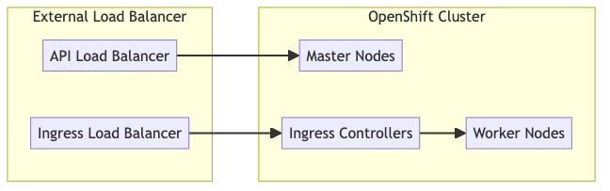

##### Firewall Rules

Required ports for RH OVE:

| Port Range | Protocol | Purpose |
| --- | --- | --- |
| 6443 | TCP | Kubernetes API server |
| 22623 | TCP | Machine config server |
| 80/443 | TCP | HTTP/HTTPS ingress |
| 9000-9999 | TCP | Host level services |
| 10250-10259 | TCP | Kubernetes node ports |
| 30000-32767 | TCP | NodePort services |

#### Security Prerequisites

##### Certificate Management

### TLS certificate configuration  
tls:  
 ca_cert: |  
 -----BEGIN CERTIFICATE-----  
 # CA certificate content  
 -----END CERTIFICATE-----  
   
 api_cert: |  
 -----BEGIN CERTIFICATE-----  
 # API server certificate  
 -----END CERTIFICATE-----

##### RBAC Configuration

Prepare service accounts and roles:

apiVersion: v1  
kind: ServiceAccount  
metadata:  
 name: rh-ove-admin  
 namespace: openshift-cnv  
---  
apiVersion: rbac.authorization.k8s.io/v1  
kind: ClusterRoleBinding  
metadata:  
 name: rh-ove-admin-binding  
roleRef:  
 apiGroup: rbac.authorization.k8s.io  
 kind: ClusterRole  
 name: cluster-admin  
subjects:  
- kind: ServiceAccount  
 name: rh-ove-admin  
 namespace: openshift-cnv

#### External System Prerequisites

##### Git Repository Setup

For GitOps implementation:

### Create GitOps repository structure  
mkdir -p rh-ove-gitops/{applications,infrastructure,policies}  
  
### Initialize Git repository  
cd rh-ove-gitops  
git init  
git remote add origin https://git.example.com/rh-ove-gitops.git

##### Rubrik Backup System

Prerequisites for Rubrik integration:

* **Rubrik cluster**: Version 5.0+
* **Network connectivity**: Cluster to Rubrik management network
* **Service account**: With backup and restore permissions
* **API access**: Rubrik REST API credentials

### Rubrik connection configuration  
apiVersion: v1  
kind: Secret  
metadata:  
 name: rubrik-credentials  
 namespace: rubrik-system  
type: Opaque  
stringData:  
 username: "rubrik-service-account"  
 password: "secure-password"  
 cluster-address: "rubrik.example.com"

##### Dynatrace Monitoring

Prerequisites for Dynatrace integration:

* **Dynatrace tenant**: SaaS or Managed
* **API tokens**: With required permissions
* **Network access**: Cluster to Dynatrace endpoints

### Dynatrace API token secret  
apiVersion: v1  
kind: Secret  
metadata:  
 name: dynakube  
 namespace: dynatrace  
type: Opaque  
stringData:  
 apiToken: "dt0c01.xxxxx"  
 dataIngestToken: "dt0c01.yyyyy"

##### ServiceNow CMDB

For CMDB integration:

* **ServiceNow instance**: With CMDB module
* **Service account**: With CMDB read/write permissions
* **API access**: REST API and webhooks configured

#### Validation Checklist

##### Pre-Installation Checks

### Validation script example  
apiVersion: v1  
kind: ConfigMap  
metadata:  
 name: pre-install-checks  
data:  
 validate.sh: |  
 #!/bin/bash  
   
 # Check OpenShift version  
 oc version  
   
 # Verify cluster resources  
 oc get nodes  
 oc get storageclass  
   
 # Check virtualization support  
 oc get nodes -o json | jq '.items[].status.allocatable'  
   
 # Validate network connectivity  
 curl -k https://registry.redhat.io/health

##### Resource Verification

### Check available resources  
oc adm top nodes  
  
### Verify storage classes  
oc get storageclass  
  
### Check network plugins  
oc get network.config/cluster -o yaml  
  
### Validate image registry access  
oc get imagestreams -n openshift

#### Installation Timeline

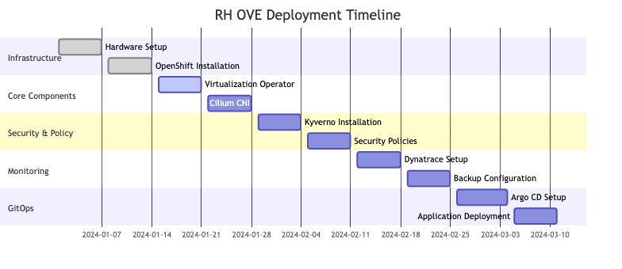

This comprehensive prerequisites guide ensures all necessary components and configurations are in place before beginning the RH OVE deployment process.

## Installation

### Installation Guide

#### Overview

This installation guide provides step-by-step instructions to deploy the RH OVE ecosystem using a multi-cluster architecture. The deployment follows a hub-and-spoke pattern with one management cluster and multiple application clusters for different environments (production, staging, development).

#### Multi-Cluster Architecture

The RH OVE ecosystem consists of:

* **1 Management Cluster**: Centralized control plane for governance, policy, monitoring, and GitOps
* **N Application Clusters**: Dedicated workload execution environments for virtual machines and containers

#### Installation Flow

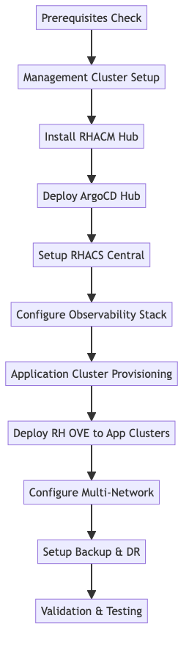

#### Core Component Installation

##### OpenShift Cluster Setup

1. **Install OpenShift**
   * Follow [OpenShift Installation Docs](https://docs.openshift.com/) to set up the cluster.
   * Choose between IPI or UPI depending on your infrastructure.
2. **Verify Cluster Health**

* oc get nodes  
  oc get pods -n openshift-apiserver

##### Virtualization Operator

1. **Install OpenShift Virtualization**

* oc apply -f https://path/to/virtualization-operator.yaml

1. **Verify Installation**

* oc get pods -n openshift-cnv  
  oc get kubevirt.kubevirt.io/kubevirt -n openshift-cnv

##### Cilium CNI

1. **Install Cilium**

* helm repo add cilium https://helm.cilium.io/  
  helm install cilium cilium/cilium --namespace kube-system

1. **Verify Cilium Status**

* cilium status

##### Kyverno Policy Engine

1. **Install Kyverno**

* kubectl create -f https://github.com/kyverno/kyverno/releases/download/v1.5.2/install.yaml

1. **Apply Policies**

* kubectl apply -f /path/to/policy-files

#### Monitoring Setup

##### Dynatrace Integration

1. **Install Dynatrace Operator**

* oc apply -f https://path/to/dynatrace-operator.yaml

1. **Configure DynaKube**

* oc apply -f /path/to/dynakube-config.yaml

1. **Verify Monitoring**

* oc get pods -n dynatrace

##### Prometheus and Grafana

1. **Install Prometheus Operator**

* oc apply -f https://path/to/prometheus-operator.yaml

1. **Setup Grafana**

* oc apply -f https://path/to/grafana-deployment.yaml

#### Backup Configuration

##### Rubrik Integration

1. **Install Rubrik Operator**

* oc apply -f https://path/to/rubrik-operator.yaml

1. **Verify Backup**

* oc get pods -n rubrik

#### GitOps Setup

##### Argo CD Installation

1. **Install Argo CD**

* oc apply -n argocd -f https://path/to/argocd-install.yaml

1. **Access Argo CD UI**
   * Forward Argo CD API server port:
   * oc port-forward svc/argocd-server -n argocd 8080:443
2. **Login to Argo CD**
   * Open <https://localhost:8080> in your browser.
3. **Deploy Applications**

* argocd app create my-app --repo https://git.example.com/my-app --path ./  
  argocd app sync my-app

#### Security Hardening

1. **Configure RBAC**

* oc apply -f /path/to/rbac-config.yaml

1. **Enable Pod Security**

* oc apply -f /path/to/pod-security.yaml

1. **Firewall Adjustments**
   * Ensure only necessary ports are open (refer to [prerequisites](prerequisites.md)).

#### Validation Steps

##### Verify All Deployments

oc get all --all-namespaces

##### Check Monitoring Dashboards

* Confirm metrics collection in Grafana and Dynatrace.

#### Post-Installation Tasks

##### Documentation

* Update [MkDocs](../mkdocs.yml) with new components.

##### Backup Verification

* Test Rubrik backups for VM and container data.

#### Conclusion

This guide ensures a smooth installation process for RH OVE, covering all critical steps and components necessary for successful deployment and operation. Follow each section carefully to complete the installation.

## Configuration

### Deployment Configuration

#### Overview

This document provides configuration guidelines for the RH OVE deployment, focusing on customization and parameters essential for adapting the solution to your specific environment.

#### OpenShift Configuration

##### Cluster Configuration

Customize your OpenShift cluster with the necessary configurations to optimize performance and security:

apiVersion: config.openshift.io/v1  
kind: ClusterVersion  
metadata:  
 name: version  
spec:  
 channel: stable  
 upstream: https://api.openshift.com/api/upgrades_info/v1/graph  
  
### Customization to networking  
apiVersion: operator.openshift.io/v1  
kind: Network  
metadata:  
 name: cluster  
spec:  
 clusterNetwork:  
 - cidr: 10.128.0.0/14  
 hostPrefix: 23  
 serviceNetwork:  
 - 172.30.0.0/16

##### Node Configuration

Optimize your nodes for workload management:

apiVersion: machineconfiguration.openshift.io/v1  
kind: MachineConfigPool  
metadata:  
 name: worker  
spec:  
 machineConfigSelector:  
 matchExpressions:  
 - key: machineconfiguration.openshift.io/role  
 operator: In  
 values:  
 - worker  
 nodeSelector:  
 matchLabels:  
 node-role.kubernetes.io/worker: ""  
  
### Taints to manage workloads effectively.  
apiVersion: v1  
kind: Node  
metadata:  
 name: node-1  
spec:  
 taints:  
 - key: app  
 value: high-performing  
 effect: NoSchedule

#### Network Configuration

Customize your Cilium CNI settings:

apiVersion: cilium.io/v2  
kind: CiliumNetworkConfig  
metadata:  
 name: cilium-config  
spec:  
 endpointRoutes: true  
 devices:  
 - eth0  
 autoDirectNodeRoutes: true  
  
### Policy for specific namespace isolation requirements  
apiVersion: cilium.io/v2  
kind: CiliumNetworkPolicy  
metadata:  
 name: namespace-isolation-policy  
 namespace: critical-apps  
spec:  
 endpointSelector:  
 matchLabels:  
 app: critical-environment  
 ingress:  
 fromEndpoints:  
 - matchLabels:  
 access: dedicated

#### Storage Configuration

Manage your storage setups efficiently:

apiVersion: storage.k8s.io/v1  
kind: StorageClass  
metadata:  
 name: performance-storage  
provisioner: ebs.csi.aws.com  
parameters:  
 type: io1  
 iopsPerGB: "50"  
 encrypted: "true"  
reclaimPolicy: Retain  
volumeBindingMode: WaitForFirstConsumer  
  
### PVC for critical workloads needing high IOPS  
apiVersion: v1  
kind: PersistentVolumeClaim  
metadata:  
 name: critical-workload-pvc  
spec:  
 accessModes:  
 - ReadWriteOnce  
 resources:  
 requests:  
 storage: 100Gi  
 storageClassName: performance-storage

#### Security Configuration

Strengthen the security of your deployment:

### Role-based access control  
apiVersion: rbac.authorization.k8s.io/v1  
kind: Role  
metadata:  
 namespace: secure-namespace  
 name: critical-role  
rules:  
- apiGroups:  
 - ""  
 resources:  
 - pods  
 - services  
 verbs:  
 - get  
 - list  
 - watch  
  
### Pod Security Policies  
apiVersion: policy/v1beta1  
kind: PodSecurityPolicy  
metadata:  
 name: restricted-psp  
spec:  
 privileged: false  
 allowPrivilegeEscalation: false  
 requiredDropCapabilities:  
 - ALL  
 volumes:  
 - 'configMap'  
 - 'emptyDir'  
 - 'persistentVolumeClaim'

#### Conclusion

By properly configuring these parameters, you can ensure that your RH OVE deployment is optimized for performance, security, and operational effectiveness. Adjust configurations based on specific organizational policies and workload demands.